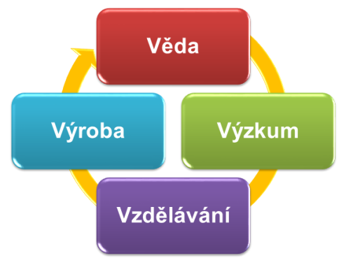

VVVV 2016

Název/Title

CELá JMÉNa¹⁾ full names ²⁾
¹⁾ Afiliace
²⁾ Affiliation
E-mail

Abstrakt (50-200 slov) / Abstract (50-200 words) / Abstrakt (50-200 slov) / Abstract (50-200 words) / Abstrakt (50-200 slov) / Abstract (50-200 words) / Abstrakt (50-200 slov) / Abstract (50-200 words) / Abstrakt (50-200 slov) / Abstract (50-200 words) / Abstrakt (50-200 slov) / Abstract (50-200 words) / Abstrakt (50-200 slov) / Abstract (50-200 words) / Abstrakt (50-200 slov) / Abstract (50-200 words) / Abstrakt (50-200 slov) / Abstract (50-200 words) / Abstrakt (50-200 slov) / Abstract (50-200 words) / Abstrakt (50-200 slov) / Abstract (50-200 words) / Abstrakt (50-200 slov) / Abstract (50-200 words) /

Vyplněný abstrakt zašlete na e-mail sis@csvts.cz

